**Project Title: UI Design and Prototyping OF IDEATION**

**1. Introduction**

* My website idea is the creation of a market place for dogs. Where dog lovers, breeders and veterinary doctors will find the perfect breed for of their choice. Whatsoever your financial constraints might be, an easy convenient payment plan can be worked out.
* Features include:
  + a menu button, containing all categories of dog breeds
  + A homepage which displays a jumbotron with hot deals, a search button, a list of recommended products currently available in the market
  + Various products page consisting of details of specific items listed on the homepage.
  + Product page links to a checkout page

**2. User Interface Design and Prototype**

* I design the U.I using the mobile first approach.
* The pages are displayed in the logical order in which a user will proceed in making a request.
* First the homepage, second the menu displaying categories of breeds, third product page after an item is selected, fourth a confirmation page where users put in there card details(shopping cart), fifth is the confirmation of order page, and links to other products.
* 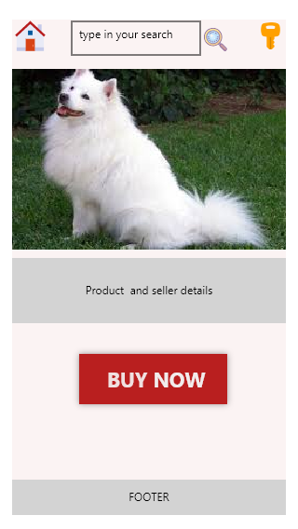

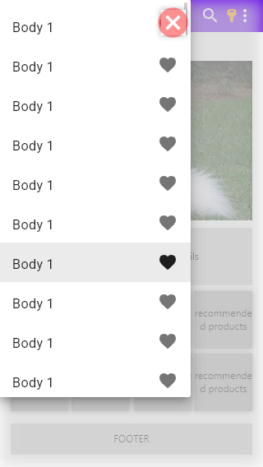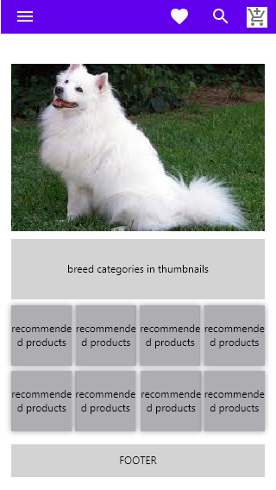

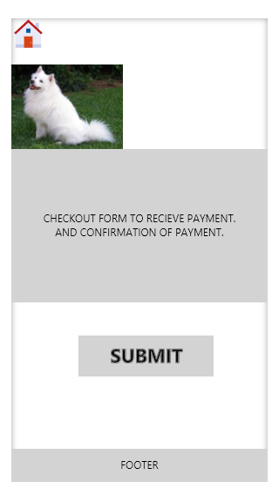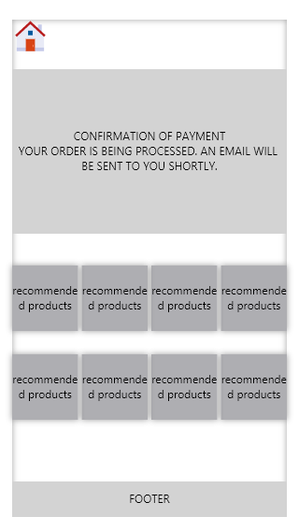

**3. Navigation Structure**

[**https://www.figma.com/proto/iku0U6e5eT7KF1j3wjwDOE/Ideation-Dog-project?node-id=0%3A2&viewport=79%2C171%2C0.5&scaling=min-zoom**](https://www.figma.com/proto/iku0U6e5eT7KF1j3wjwDOE/Ideation-Dog-project?node-id=0%3A2&viewport=79%2C171%2C0.5&scaling=min-zoom)

Above is a link to the prototype of the page on figma.

**4. References**

* [www.jumia.com](http://www.jumia.com)
* [www.amazon.com](http://www.amazon.com)